Hill Stations:

Chitral

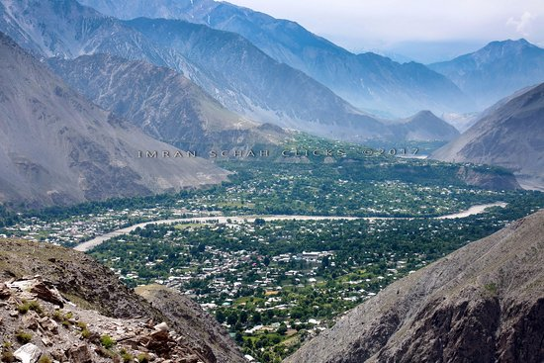

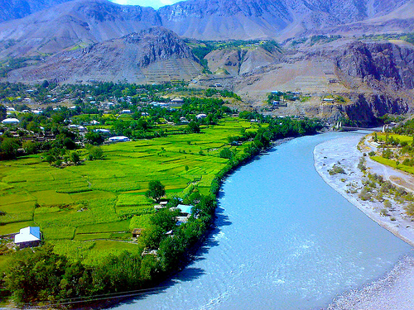

**Chitral** Khowar : Khowar for "field") is the capital of the Chitral District, situated on the Chitral River in northern Khyber Pakhtunkhwa, Pakistan. Chitral also served as the capital of the princely state of Chitral until 1969.